Lab 8: Building a Neural Network Model to Identify Diabetic Patients

Brandon Trinkle

Arizona State University

Course Number: IFT 360

Professor Durgesh Sharma

9/29/24

**Question 1:** *Run the code and make sure you are not getting any errors. What is the obtained accuracy?*

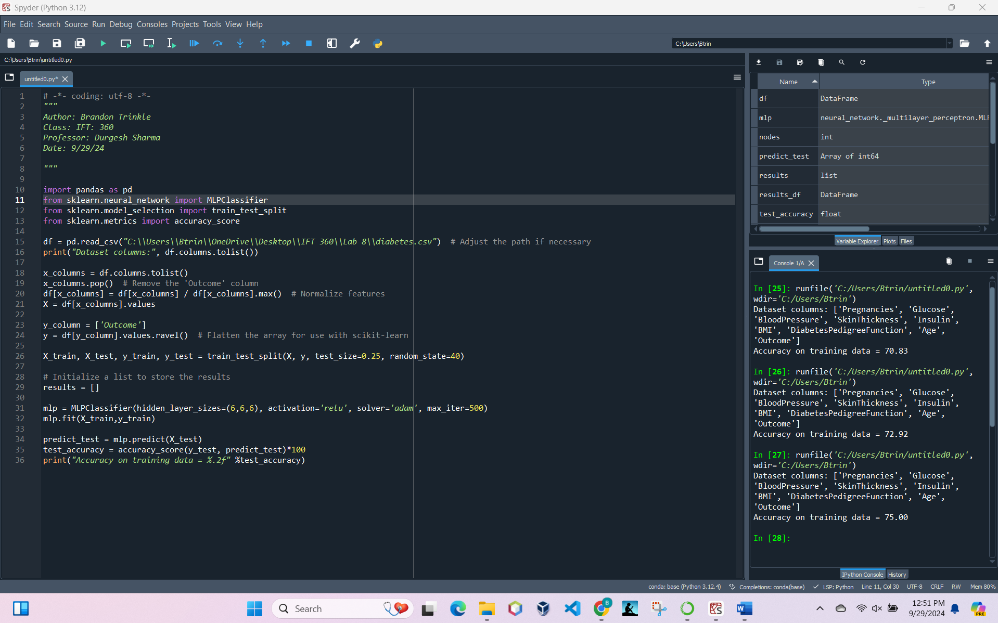

Print output:

* Dataset columns: ['Pregnancies', 'Glucose', 'BloodPressure', 'SkinThickness', 'Insulin', 'BMI', 'DiabetesPedigreeFunction', 'Age', 'Outcome']
* Accuracy on training data = 75.00

**Question 2:** *Try to change the number of nodes in each hidden layer from 3 to 9. Do you notice any significant changes in the obtained accuracy?*

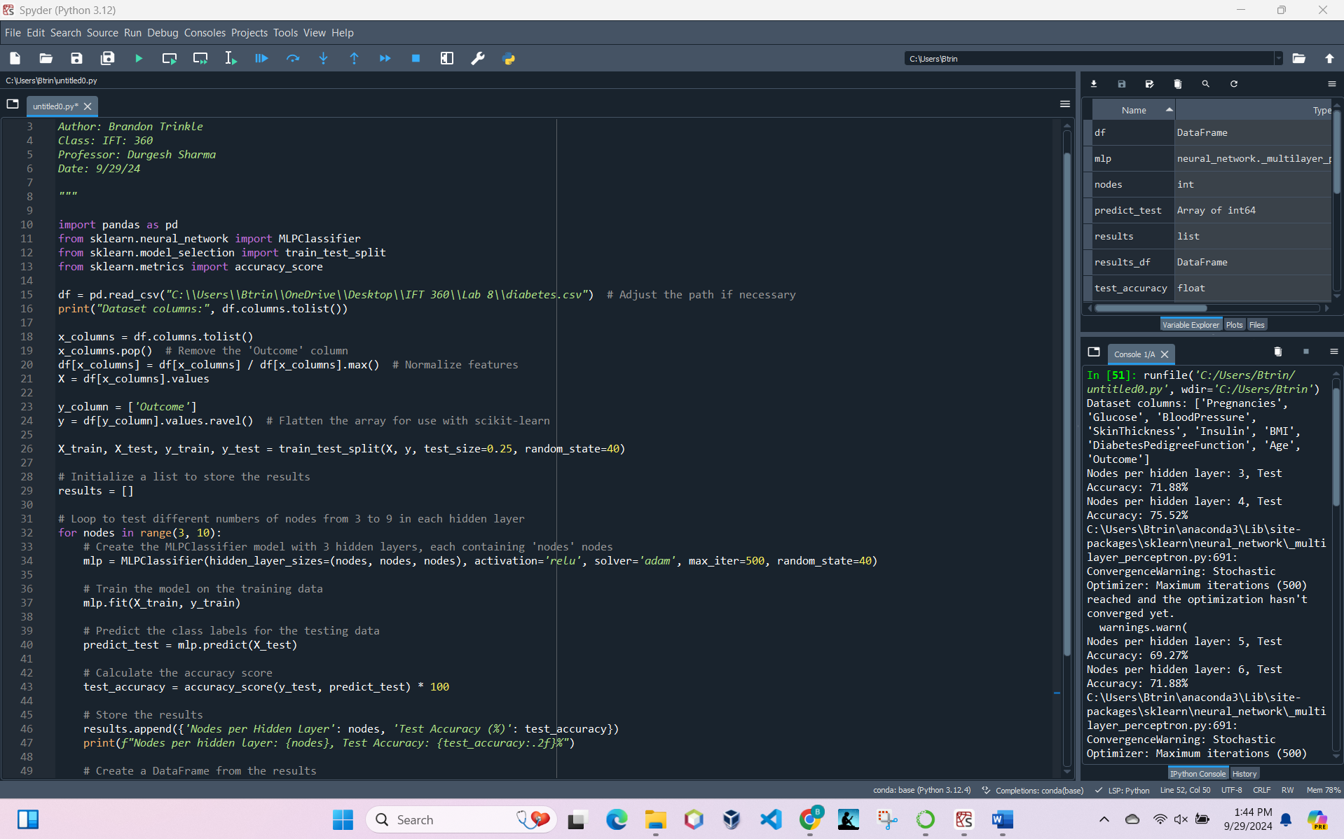

These screenshots highlight a few changes. I created a loop to iterate the number of nodes from 3 to 9, and output the accuracy for each. First, we can see an error message in the output for nodes 4 and 6. This error message is telling me that the number if iterations set at 500 is not enough to reach optomization. To fix this, we need to increase this portion of the code “max_iter=500”. The next output, I changed max_iter=500, to max_iter=5000. Here is the next output.

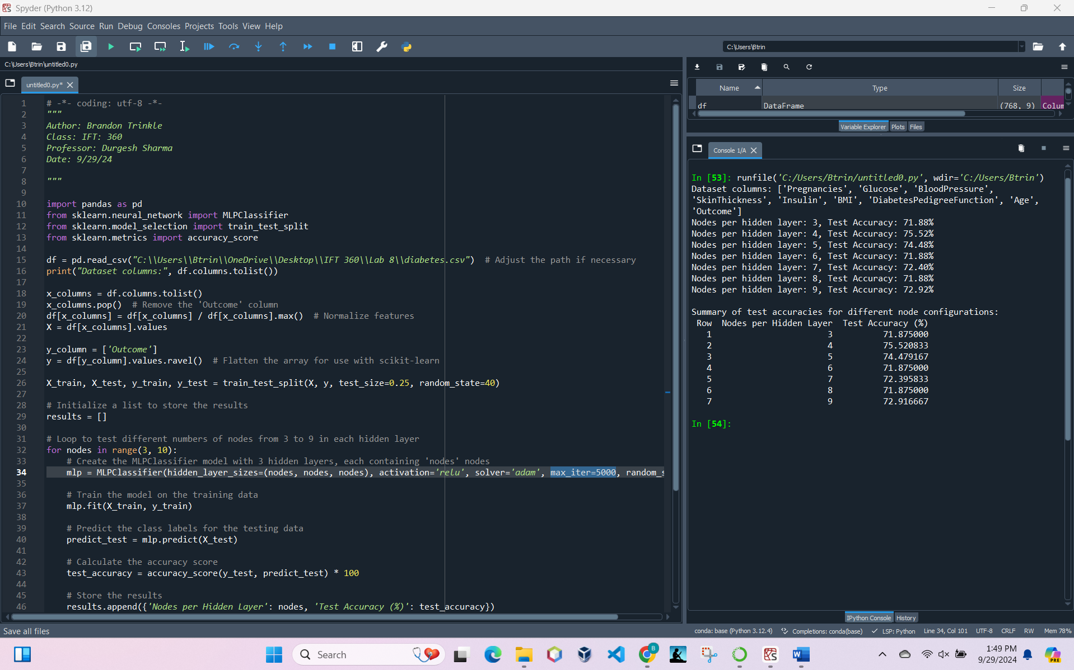

As you can see from this screenshot, we were able to obtain a result without a warning.

**Conculsion**

Based on the output, we can conclude that adding additional nodes beyond 4, does not improve performance within this data model. We can see that node 4 performs the best, and that nodes 5 and beyond do slightly worse.